**Project 5:**

**Working with S3:**

Step 1: Create a S3 bucket

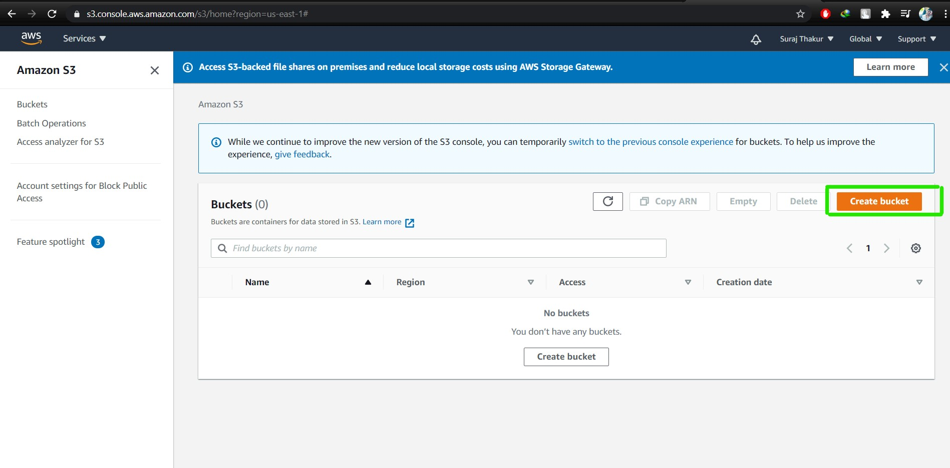

Step 2: While creating bucket provide permission for Public access

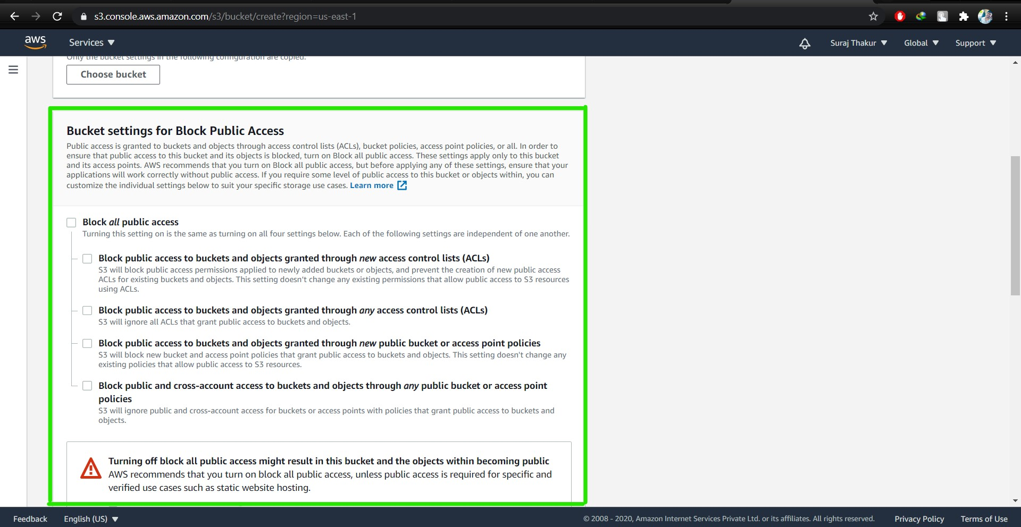

Step 3: Bucket Versioning  
Note: Bucket Versioning should be enabled while creating the bucket

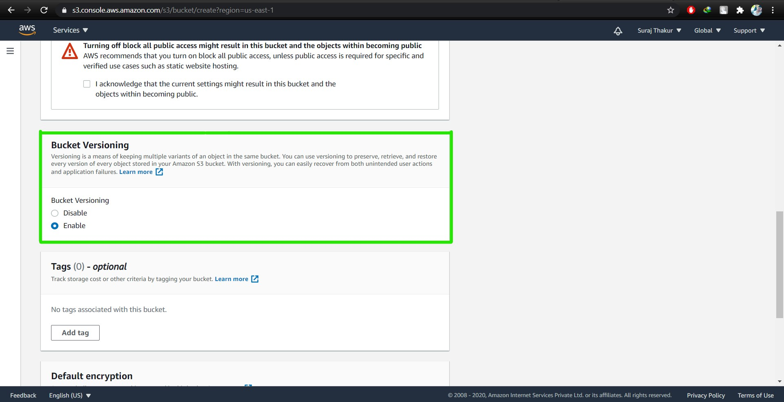

Step 4: After the creation of bucket, upload text document files in the bucket.

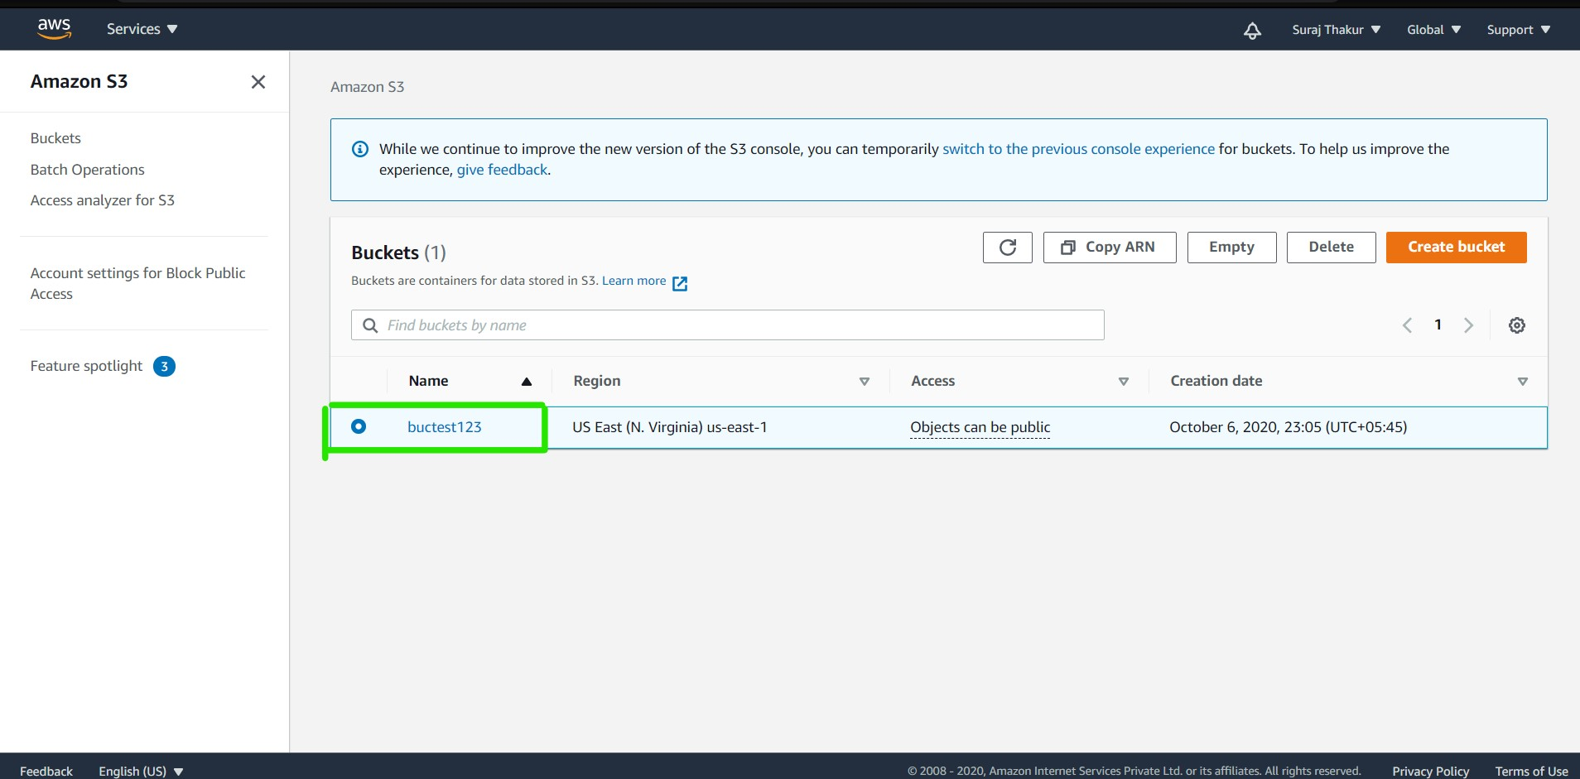

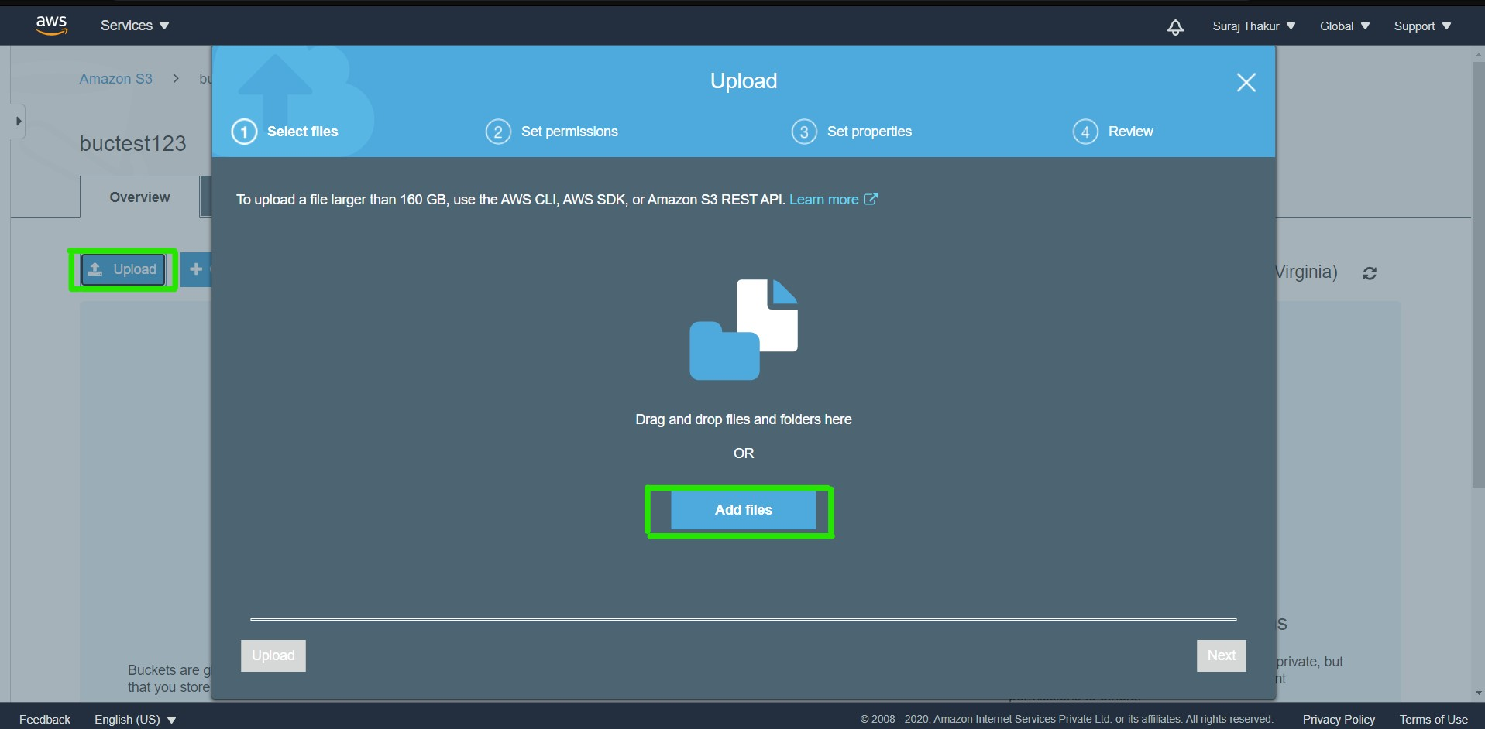

Step 5: The objects inside the bucket should be made public to order to access it publicly

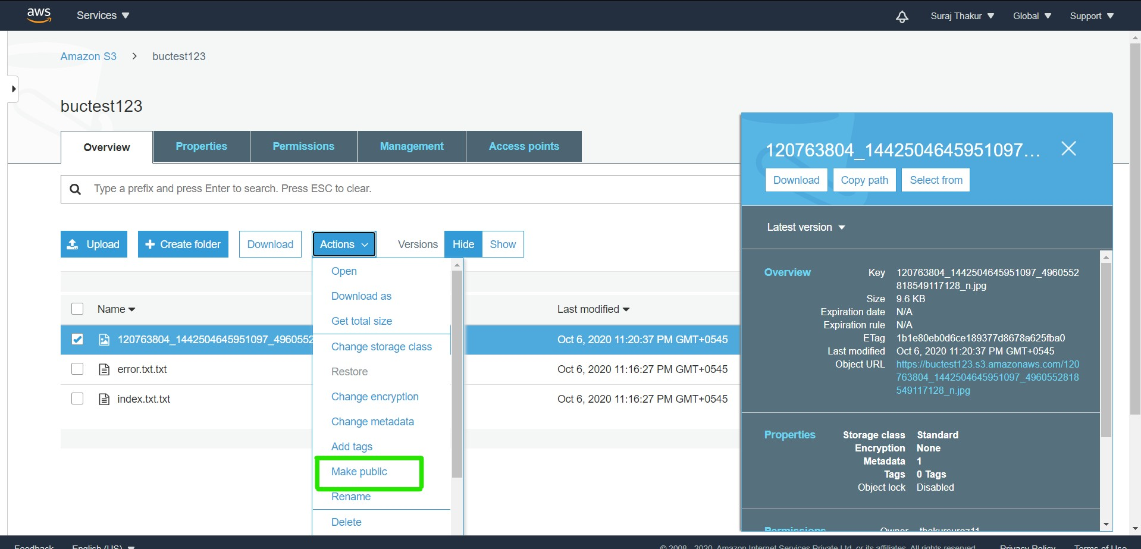

Step 6: Now static web hosting is done using the S3 bucket

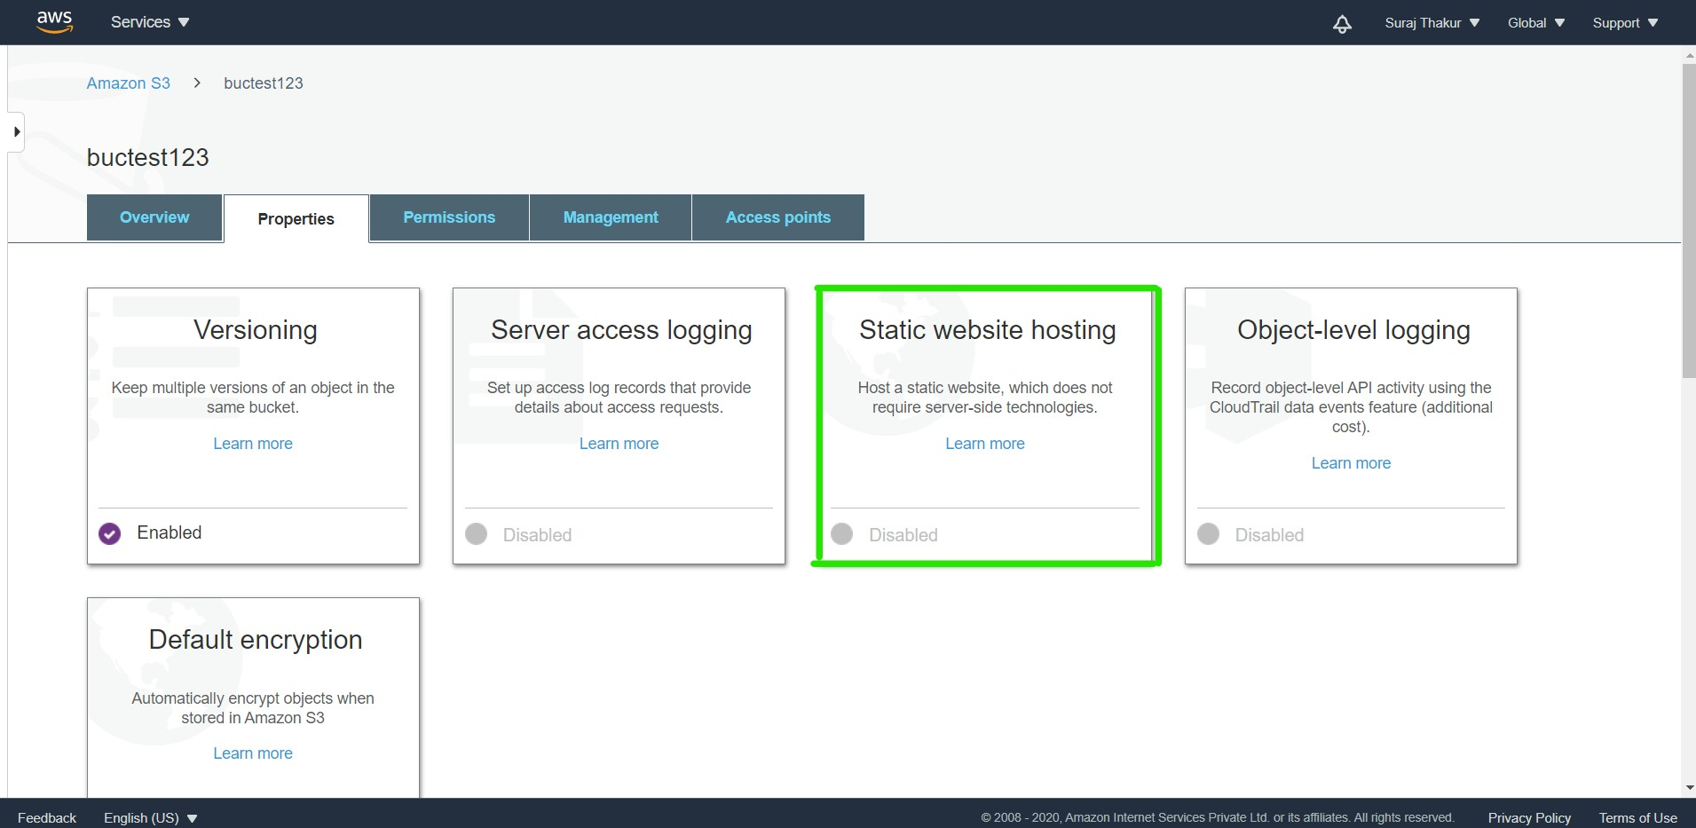

Step 7: Inside static web hosting, two files: index.txt and error.txt are placed.

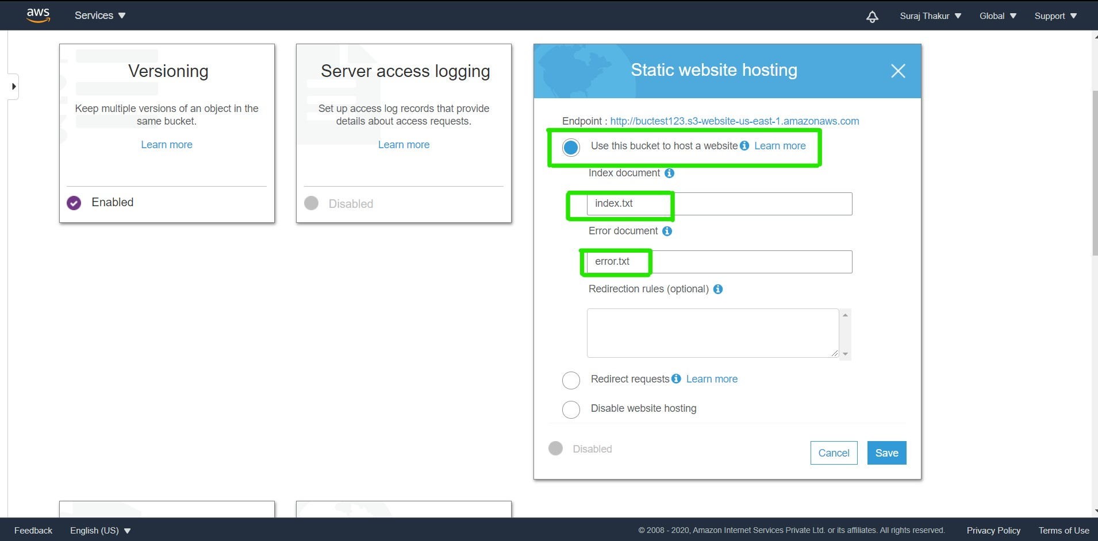

Note: Both the text documents should be made public manually.

Step 8: Opening the Object URL of the files/objects in new tab of your browser check whether it is public or not.

In this case, it is public

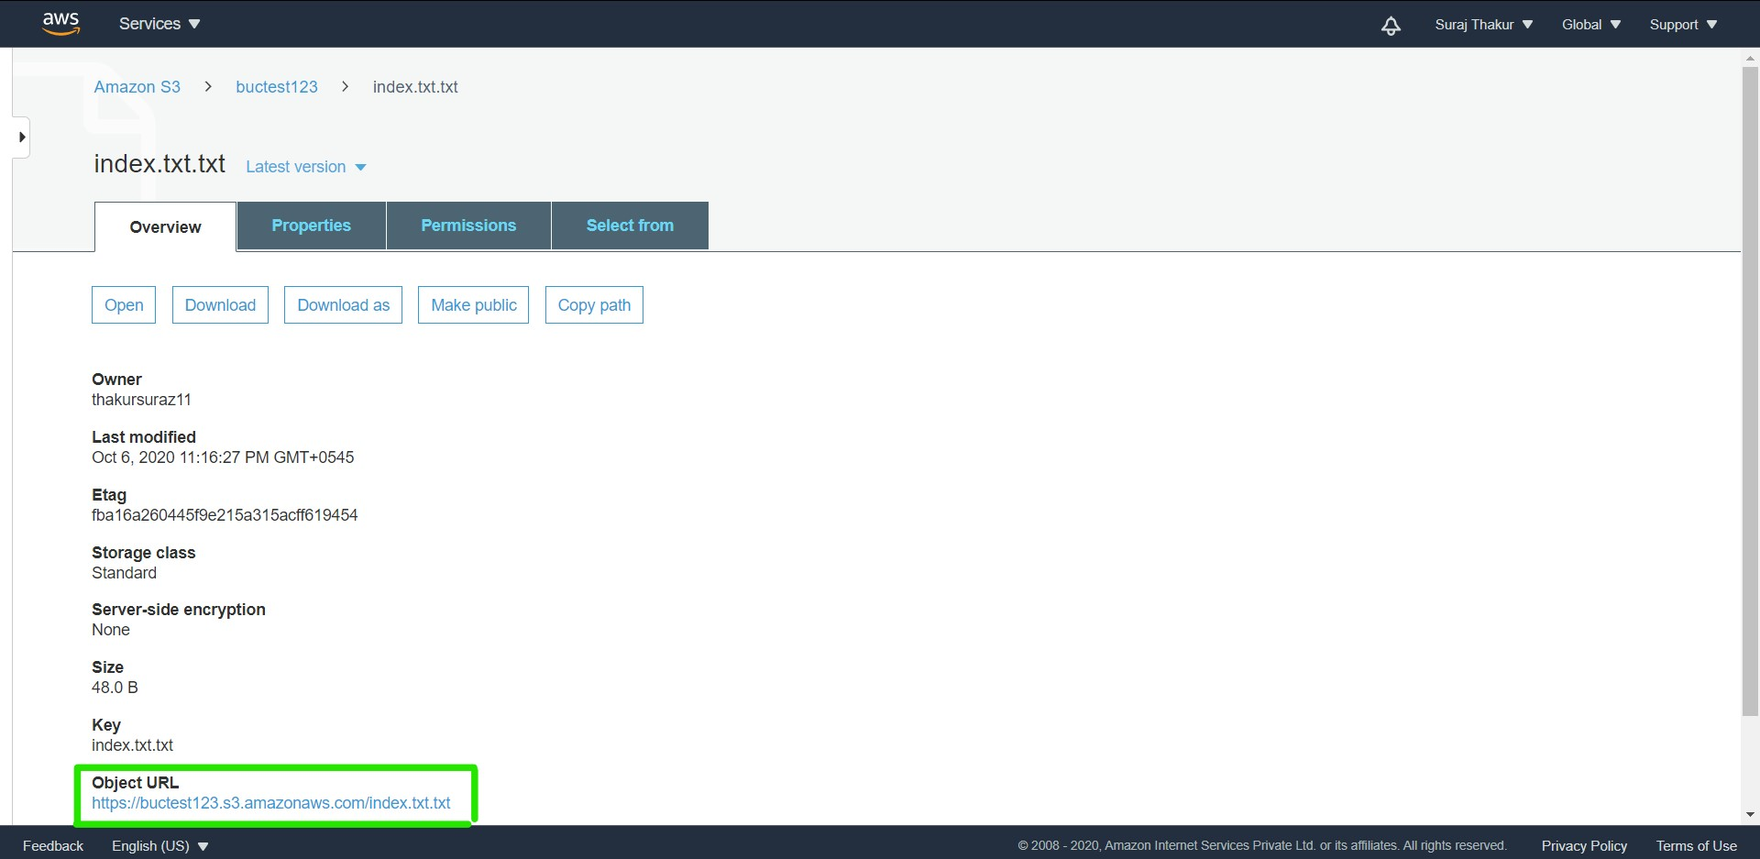

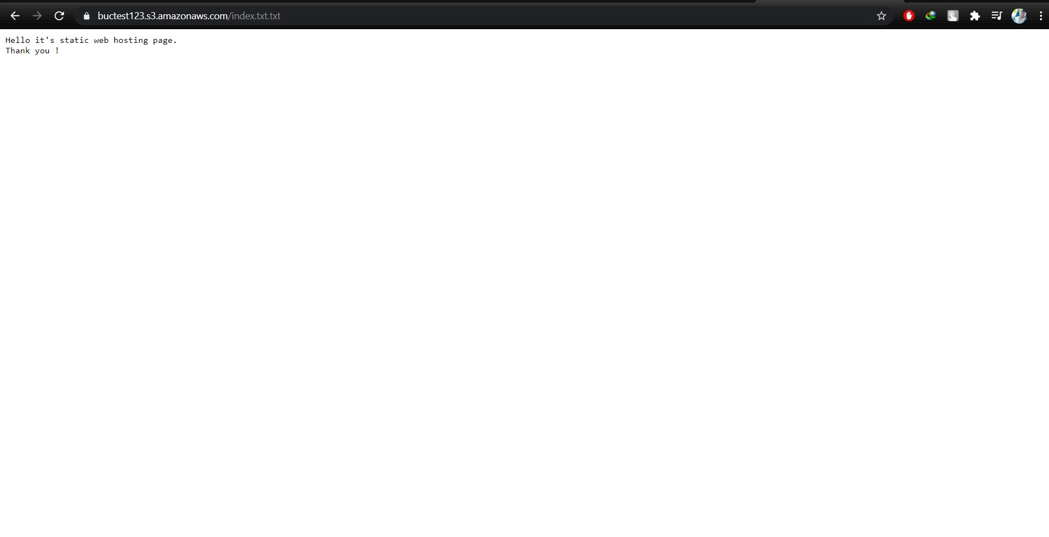

Same process for Image that I’ve uploaded in my S3 Bucket:

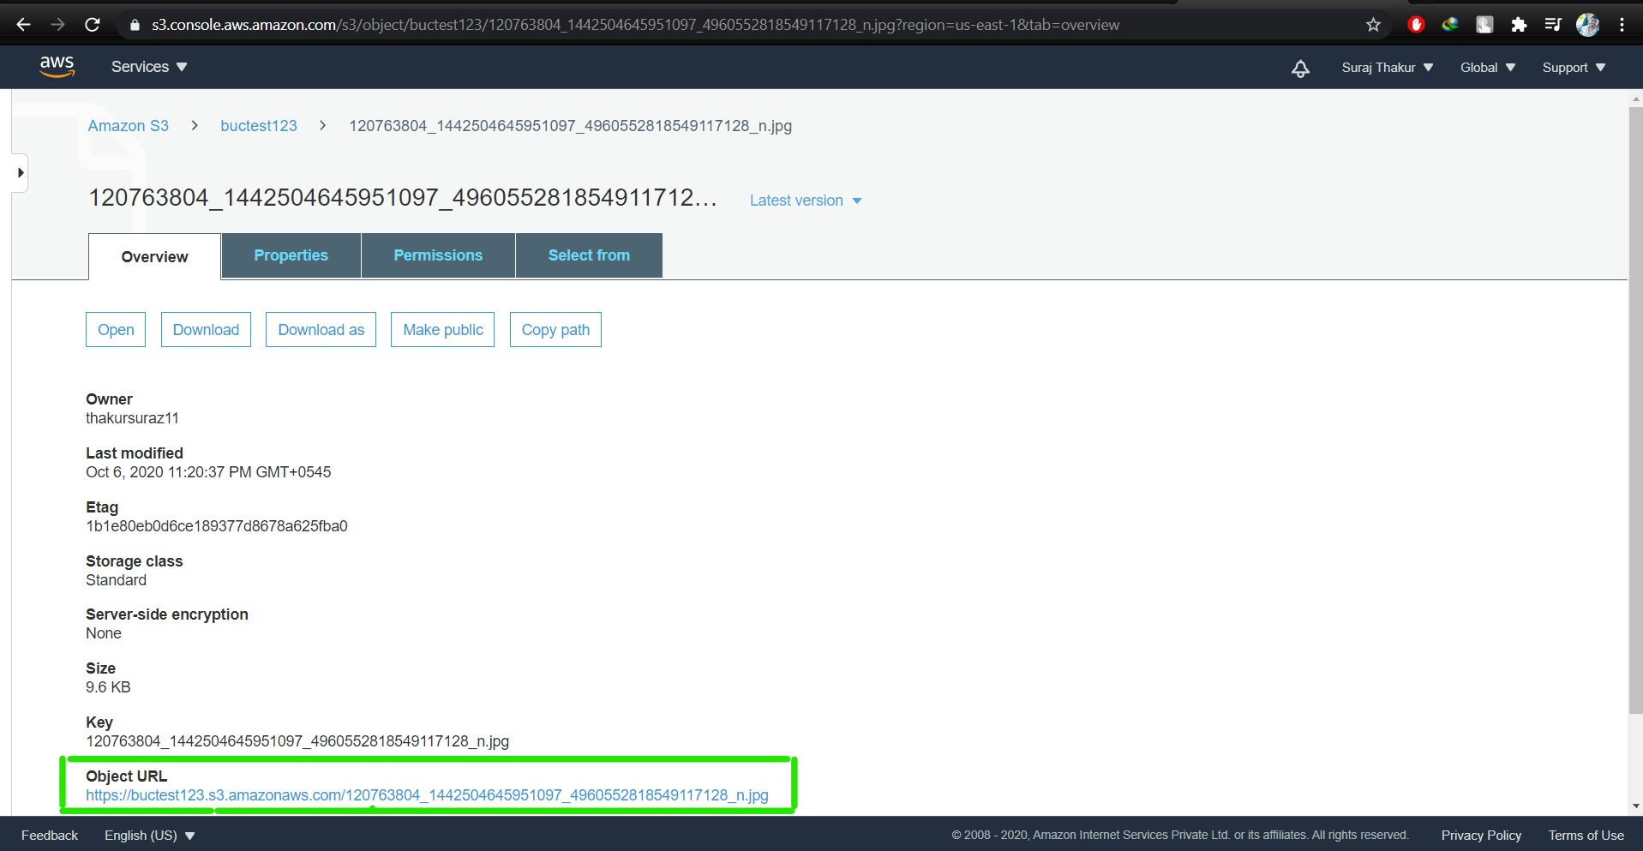

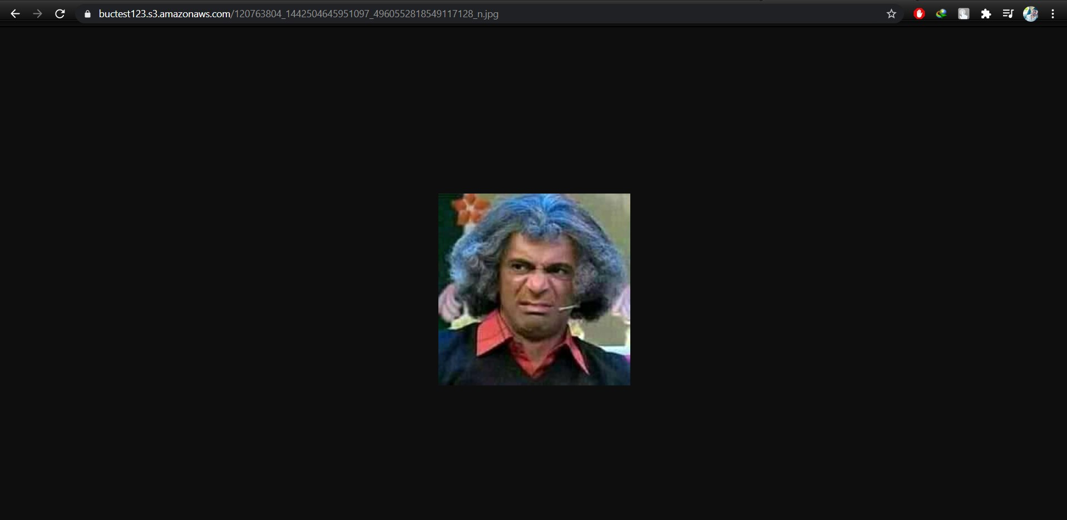

Step 9: **Working with Versioning**

In production environment, versioning manages the entire process of managing the versions. It is a kind of backup. We need a place where all the versions are stored of the same object. In case if we lose our object, versioning keeps all the records that can be retrieved again.

We can show and hide the versions of an object by single click on the hide/show tab:

